HackerEarth - Count Divisors
Code:
#include <stdio.h>

int main() {
int l, r, k;
scanf("%d %d %d", &l, &r, &k);

int count = 0;
for (int i = l; i <= r; i++) {
if (i % k == 0) {
count++;
}
}

printf("%d\n", count);
return 0;
}

Screenshot:

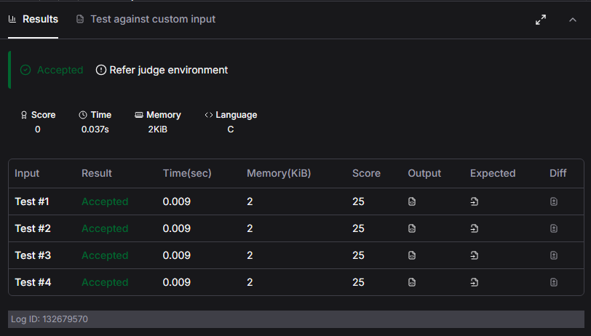

Link:
https://www.hackerearth.com/practice/basic-programming/input-output/basics-of-input-output/practice-problems/algorithm/count-divisors/

